SPARX4EDGY23
  - EDGY23 MDG for sparx enterprise archItect
Rudi Claes
rudi.claes@inno.com

Management summary
EDGY is an open Source tool for collaborative Enterprise Design. SPARX4EDGY23 is available as a free extension (MDG technology) for Sparx Enterprise Architect. This whitepaper introduces EDGY and SPARX4EDGY23 , and illustrates how Sparx EA can be used for end-to-end modeling based on EDGY.

Table of contents
EDGY 2
SPARX4EDGY23 5
OPTIMIZING EDGY WITH SPARX 9

OTHER RESOURCES
GETTING STARTED SPARX4EDGY23 - Getting started.pdf
EDGY https://enterprise.design/wiki/Home
EDGY TOOLS https://enterprise.design/wiki/EDGY:Tools
EDGY23 EXAMPLES EDGY23.qea

EDGY
EDGY is an open Source tool for collaborative Enterprise Design created by the Intersection Group. This tool covers the essential activities needed to create better enterprises: clarifying and exploring challenges, understanding the current configuration of enterprise elements and collaboratively charting potential futures.
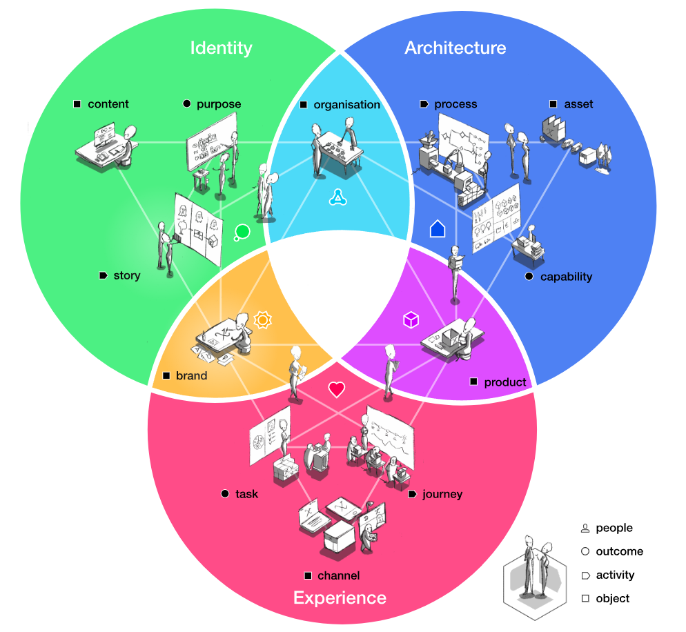
Fig.1 EDGY overview
In order to achieve this, EDGY consists of the following building blocks (see figure 1):
- Facets: provide useful lenses to understand why an enterprise exists (Identity), what it is supposed to deliver to whom (Experience), and how all of this is supposed to work (Architecture). As such, each facet represents a fundamental big picture question behind an enterprise under investigation
- Intersections: are the overlap between two facets answering questions that are "on the edge" of particular viewpoints and corresponding disciplines present in the enterprise. How do we organise ourselves as a team (Organisation)? What do we make and offer to people (Product)? What is our reputation and image when people are in touch with us and our offerings (Brand)?
- Elements: EDGY includes a simple but rich and expressive visual language of only four elements (People, Outcome, Activity, Object) that can be universally used across design challenges/disciplines. These are available by means of specialization in the various facets and intersections (see figure 2)
- Relationships: EDGY defines three types of relationships each of which can connect two elements (see figure 3). A Link describes an association, a Flow describes a behaviour or dynamic sequence, and a Tree describes a containment or aggregation between a parent and a child element (of the same type)
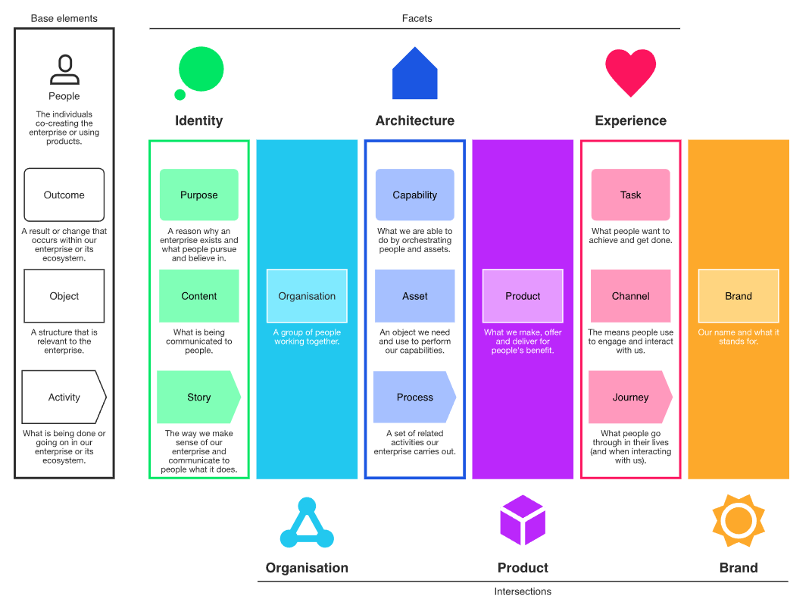
Fig.2 EDGY elements
EDGY defines four generic elements to describe what is happening in an enterprise and its ecosystem:
- People: the individuals co-creating the enterprise or using products
- Outcome: a result or change that occurs within our enterprise or its ecosystem
- Activity: what is being done or going on in our enterprise or its ecosystem
- Object: a structure that is relevant to the enterprise
EDGY defines twelve specialized elements that populate the facets and intersections (see figure 1 and 2):
- Purpose: a reason why an enterprise exists and what people pursue and believe in
- Story: the way we make sense of our enterprise and communicate to people what it does
- Content: what is being communicated to people
- Organisation: a group of people working together
- Capability: what we are able to do by orchestrating people and assets
- Process: a set of related activities our enterprise carries out
- Asset: an object we need and use to perform our capabilities
- Product: what we make, offer and deliver for people's benefit
- Task: what people want to achieve and get done
- Journey: the events and activities people experience in their lives
- Channel: the means people use to engage and interact with us
- Brand: our name and what it stands for

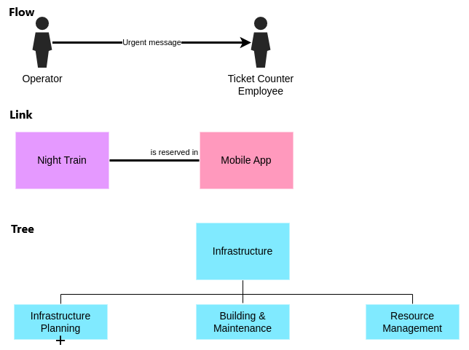
Fig.3 EDGY relationships
EDGY defines three types of relationships each of which can connect two elements (see figure 3):
- Flow: expresses a behaviour or dynamic sequence between two elements. The flow relationship is unidirectional, describing a source and a target endpoint
- Link: defines an association between two elements. By default it is non-directional and unnamed and just shows that the two elements are related. Links can also be made directional by giving them a direction and a name
- Tree: describes containment or aggregation between a parent and a child element of the same type. The flow relationship is unidirectional, describing a source and a target endpoint
EDGY also provides two kinds of labels that can be added to an element in order to indicate additional information about it (see figure 4):
- Tags: differentiate elements based on a set of values, such as an asset of type "machine" or "data" or a channel being "physical" or "digital"
- Metrics: add a quantity or quality to an element that can be measured or otherwise determined, such as a performance or satisfaction indicator
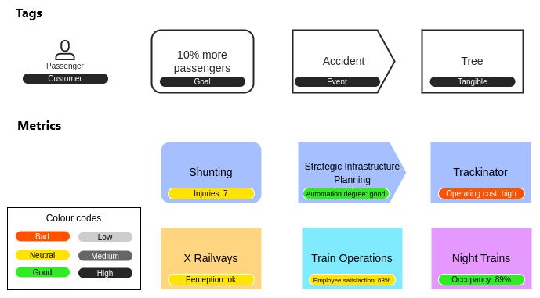
Fig.4 EDGY labels
EDGY is currently supported by several drawing and collaboration tools. But since it is a modelling language, it is ideally used in a modelling tool such as Sparx Enterprise Architect.

SPARX4EDGY23
SPARX4EDGY23 is available as a free extension (MDG technology) for Sparx Enterprise Architect. It offers a toolbox containing the complete set of EDGY elements, labels and relationships, which can be used on a dedicated diagram type (see figure 5).
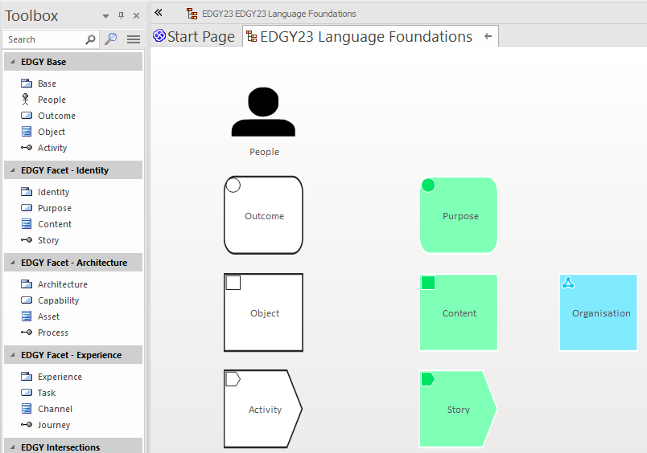
Fig.5 SPARX4EDGY23
The SPARX4EDGY23 distribution ZIP file contains the following items:
- SPARX4EDGY23 - Getting Started.pdf: shows how to install SPARX4EDGY23 and to create a sample viewpoint
- EDGY23 MDG.xml: the SPARX4EDGY23 MDG technology file that can be imported into any existing or new Sparx Enterprise Architect repository
- EDGY23.qea: the EDGY examples from the Intersection Railways case study
- SPARX4EDGY23 - Whitepaper.pdf: this document
SPARX4EDGY23 offers a “TextAlign” property with the values “Top”, “Center” and “Bottom” for all EDGY elements in order to vertically align the element name (see figure 6).
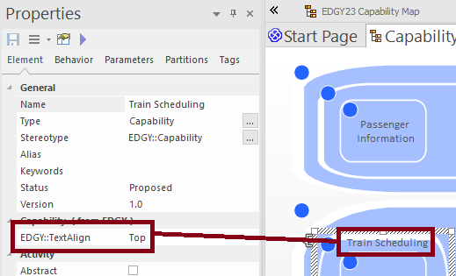
Fig.6 SPARX4EDGY23 text alignment property
The SPARX4EDGY23 toolbox contains package elements in order to create stereotyped packages for facets and intersections, as such allowing categorization and identification of related elements (see figure 7). These package elements can also be added onto diagrams for traceability purposes.
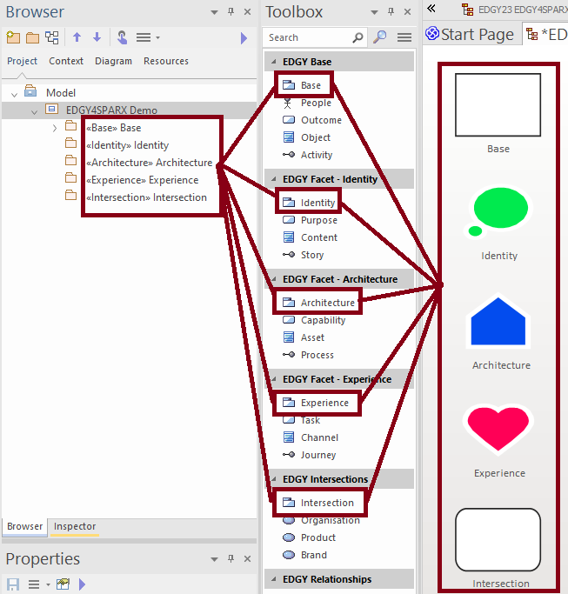
Fig.7 SPARX4EDGY23 facets and intersections as stereotyped packages
The EDGY relationships can be added onto diagrams via the SPARX4EDGY23 toolbox (see figure 8 – Option #1) or via the Quick Linker (see figure 8 – Option #2). The advantage of using the Quick Linker is that valid EDGY relationships between the source and the target element are shown and can easily be selected (when the option “Filter to Toolbox” is enabled).
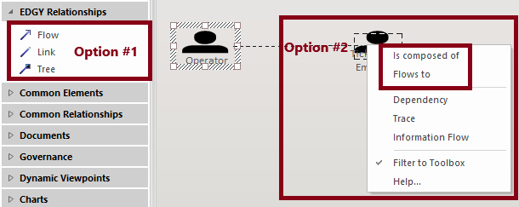
Fig.8 SPARX4EDGY23 relationships via the toolbox or the Quick Linker
EDGY provides a rich and expressive vocabulary for the Link relationship, resulting in twenty-four predefined types. These can be added via the stereotype feature of Sparx Enterprise Architect (see figure 9).
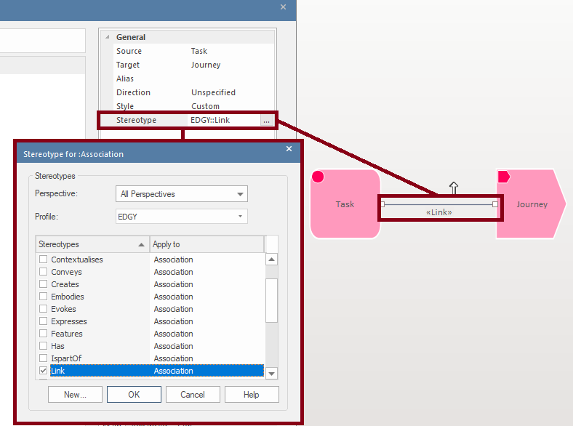
Fig.9 Adding stereotypes onto the Link relationship
The link relationship is an association between two elements. By default it is non-directional and unnamed and just shows that the two elements are related. Links can also be made directional by giving them a direction and a name. This can be done via de “Role(s)” feature of Sparx Enterprise Architect (see figure 10).
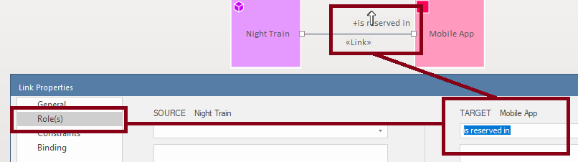
Fig.10 Making the Link relationship directional

EDGY states that the Flow and Tree relationships are unidirectional, describing a source and a target endpoint. If a bi-directional connection between elements is intended, two relationships should be defined: one from element A to element B and one from B to A. As such, this limits the options from the standard “Direction” property of relationships in Sparx Enterprise Architect to “Source -> Destination” only.
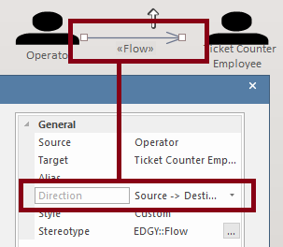
Fig.11 Flow and Tree relationships are unidirectional
EDGY also states that all three relationships can be displayed visually as a line or an arrow, but can also be expressed implicitly through proximity, containment, indentation or alignment on a grid. These implicit practices limit the traceability features of Sparx Enterprise Architect as a modeling tool with the exception of containment, as this this a standard feature of the tool (see figure 12).
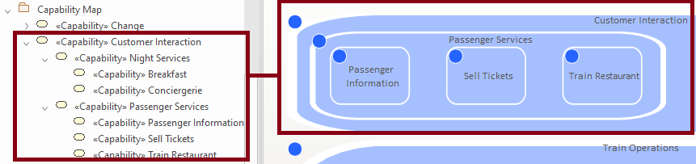
Fig.12 Containment in Sparx Enterprise Architect
The containment feature of Sparx Enterprise Architect can also be used to add tags and metrics to an element (see figure 13). The standard “Name” property of Sparx Enterprise Architect contains the name of the tag or metric. To qualify the metric, SPARX4EDGY23 offers a “MetricStatus” property with the values “Good”, “Neutral” and Bad. To quantify the metric, SPARX4EDGY23 offers a “MetricValue” property (which is a free text field).
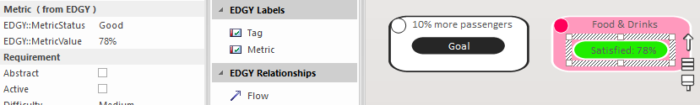
Fig.13 EDGY tags and metrics

optimizing EDGY with SPARX
EDGY enables designers, architects and change makers to co-design a coherent enterprise by identifying the most impactful perspectives and translating between them. Well-defined, reusable enterprise elements turn a complex enterprise into a set of interconnected parts, ready to be designed, mapped and transformed.
A modelling tool is then the logical choice to visualize and trace these interconnections. Sparx Enterprise Architect is perfectly suited to practice enterprise design in this fashion (see figure 14).
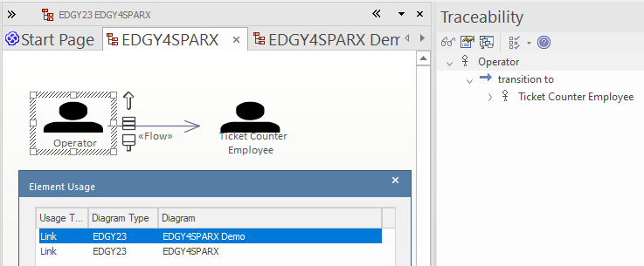
Fig.14 Traceability in Sparx Enterprise Architect
As Sparx Enterprise Architect is a general purpose modeling tool that supports all mainstream modeling languages, these can be easily reused to further detail the EDGY elements (see figure 15 and 16).
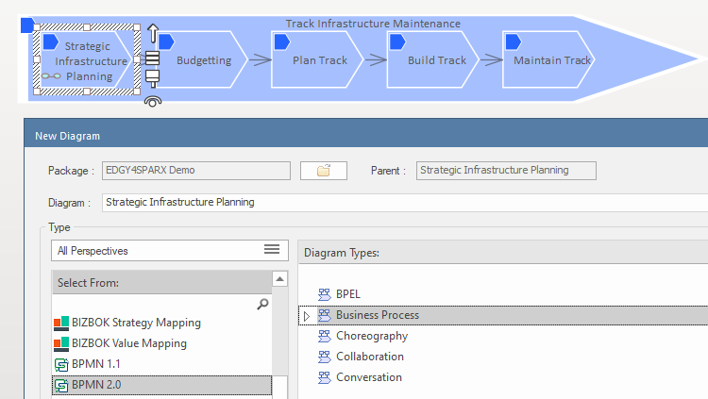
Fig.15 Detailing out an EDGY process with BPMN
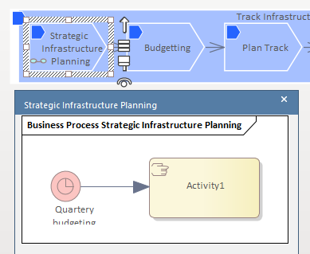
Fig.16 Sparx Enterprise Architect preview feature
As such, enterprise design with EDGY can optimized with the help of Sparx Enterprise Architect.

